MAPS
Test Strategy
&
Automation
Design Document

Author: | Gopinathan.D
Date: | 20-Dec-2011
Version # | Version 1.0
File Location: | \\StarTeam \Phase-1\MAPS\ProductTesting\MAPS_4.0_QTP_Automation\Automation_Docs

DOCUMENT ORIGIN

Revision History
Version | Date | Summary of Changes | Changes Marked
1.0 | 20-Dec-11 | Initial draft | Yes
1.1 | 21-Dec-11 | Initial draft 1.1
1.2 | 05-Jan-12 | Execution steps are appended.

Distribution List
This document has been distributed to:
Name | Reviewer | Approver | Date
QA Testing | Dattatreya. R | -
Contents
1. INTRODUCTION 2
1.1 Purpose of the Document 4
1.2 Intended Audience 4
2. INFRASTRUCTURE CONFIGURATION 5
3. HIGH LEVEL TEST AUTOMATION ARCHITECTURE 6
3.1 QTP Scripts 6
3.2 Project specific Library 6
3.3 Generic Library: 7
3.4 Application Area: 7
3.5 Shared Object Repository: 7
3.6 Input Data from Excel: 7
3.7 QTP Results: 7
4. AUTOMATION DESIGN 7
4.1 Main Script and Test suit 7
4.2 Results reporting 7
4.3 ERROR HANDLING 7
4.4 Automation Benefits 7
5. ASSUMPTIONS 8
6. DEPENDENCIES 8
7. RISKS & MITIGATIONS 8
8. GLOSSARY 9
9. RoadMap 9
10. Execution Steps 10

INTRODUCTION

Merchant Acquiring and Payment System (MAPS) is flexible, comprehensive and End to End Merchant Management System for the Acquiring Business. Merchant Acquiring System addresses all aspects of Acquiring Business namely Merchant Enrollment, Merchant Inquiries, Transaction Processing (Processing Paper Vouchers and Manual Adjustments), Payment Processing, Disputes Management, Scheme Settlements and Generating Statements and Reports. MAPS provides a unified way to connect operations across delivery channels such as Branches, POS, Internet and Payment Gateways, settlement and reporting of all monetary activities posted for each Merchant. Every Acquiring Business will be separately classified as a Financial Institution.

Merchant Acquiring Payment System (MAPS) is designed to enable efficient Acquiring Business through POS, ECOM, MOTO and Paper transactions. It provides innovative service and manages large scale acquiring efficiently. It is a unified business model that allows various products, accounts and risk schemes to be described through a set of flexible rules. Following are the major functions of Acquiring Business handled by MAPS.

- Add/Update new Merchant/Store/Terminal
- Add/Edit Merchant Account and Account Posting Rules
- Merchant and Transaction based risk

- Transaction Processing
- Scheme Settlement
- Dispute Management
- VMAS/MATCH Compliance
- Reports and Inquiry (Inquiry assists in tracking Merchant queries and complaints)

Purpose of the Document
The purpose of this document is to provide an overview of the strategy devised to automate MAPS Application. This is achieved by using the framework which is designed by QTP.

Specifically, this document covers the below details:
- High level Test Automation architecture.
- Test Automation Strategy.
- Dependencies and Risks involved with regard to automating MAPS Application.

Intended Audience
This document is intended for functional test team and testers to understand Automation framework which is developed for MAPS Application.

INFRASTRUCTURE CONFIGURATION

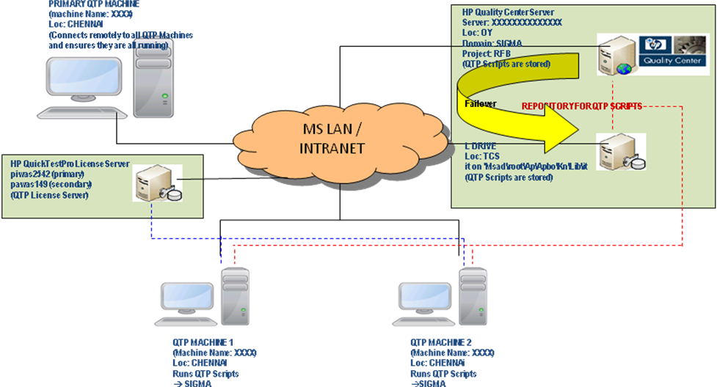

Note: Above diagram represents a pictorial but not exactly

HIGH LEVEL TEST AUTOMATION ARCHITECTURE

The Automation framework for MAPS would be modular, functionality driven testing framework and structured in following manner:

- Modularity-driven testing

The test script modularity framework requires the creation of small, independent scripts that represent modules, sections, and functions of the application-under-test. These small scripts are then used in a hierarchical fashion to construct larger tests, realizing a particular test case.

- Data-driven Testing

Data-driven testing is a framework where test input and output values are read from data files (data pools, ODBC sources, csv files, Excel files, ADO objects, and such) and are loaded into variables in captured or manually coded scripts. In this framework, variables are used for both input values and output verification values. Navigation through the program, reading of the data files, and logging of test status and information are all coded in the test script.
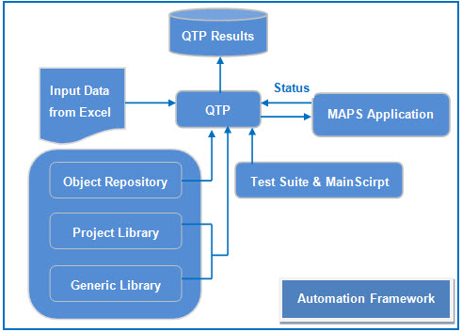

Automation Elements:

QTP Scripts (Test suit):

- Entire scripts which are automated for the application is maintained at the module / Screen level.
- Based on the requirement, modules are executed either independently or Combined.
- Execution of QTP main script gives the call to respective functions in the project specific library which is supported by generic library and the respective shared OR.

Project specific Library:
This Project specific Library is a collection of VB Script (VBS) files and these files will have the project specific functions to handle module level and screen level test scenarios.

Generic Library:
This library is a collection of VB Script (VBS) files and these files will consist of general functions and useful for invoking the shared OR and executable Test suit.

Application Area:
The application area would contain the reference to functional libraries and object repository. This application area will be associated with the Test suit.

Shared Object Repository:
Objects will be stored in Object Repository. Each Module/Sub Module has its own repository. This repository is shared among module/sub modules.

Input Data from Excel:
This Excel contains the set of test data for the corresponding function.

QTP Results (O/P):
QTP results would be saved in Results folder in Excel format.

AUTOMATION DESIGN

MAPS automation is planned in multiple phases

This automation test design execution is based on the base DB dump, which consist of set of data necessary for to run the modules either independently or combined with other modules. The main intention of this automation design is to execute the test scenarios based on the respective modules wise or test case wise. This automation approach will support both. Entire module can be executed with the necessary base dump and with the set of test data on the other end. Specific set of test cases also be executed.

Main Script and Test suit

The main QTP script will invoke the necessary module and the test cases to be executed The main script will be supported by a set of necessary generic library files which in turn load the required module level object repository and the necessary reference excel sheet used for retrieving the data. Each script will be associated with the corresponding function, in that function Entire test scenario is covered with the detailed test steps. The above logic is covered for the Entire Test suit.

Results reporting
Each module level results will be available in the Results folder of the automation framework. With the respective Pass / Fail status and description. The test step in which results are failed also captured along with the status which will be useful in Quick debugging purpose.

Error Handling
Basic Error Handling at code level is maintained for each script for proper execution

Automation Benefits
Some of the key benefits of Automation are listed below
- Reduce manual effort and hence save time to give more scope for testers to test in different areas of the application.
- Tests perform precisely the same operations each time they are run, thereby eliminating human error.
- You can reuse tests on different versions of an application after doing the necessary update.
- Saving in time during the execution of different modules.
- Respective modules and even respective test cases alone are tested with this frame work approach.

ASSUMPTIONS
Some of the prerequisites are as follows:
- Application should be stable.
- All the required software’s needs to be installed in the machine as a prerequisite to running MAPS applications.

DEPENDENCIES
Some of the dependencies are as follows:
Manual MAPS team provides the following:
- Necessary SFF file for transaction processing should be placed at the necessary path.
- Scheme incoming and necessary reject file should be placed for each execution
- The test Environment should be maintained properly as in this approach base DB dump is maintained for executing Test scenarios.
- Automation test User login id should not be allowed for manual testing purpose.

RISKS & MITIGATIONS
This section lists the risks identified during the feasibility analysis phase:

# | Risks Identified | Mitigation Plan
 | UI changes made to the applications involved in automation during the automation phase | Function is using combination of descriptive and OR based approach. Most of the function will identify the objects correctly.  GUI scripts needs to be executed to identify the major GUI level changes.
 | Any functionality update or change has been done in MAPS Application | All changes need to be intimated to the automation team on a regular basis.
 | QTP Machine is down. | - Move all the scripts to backup machine.  - Create automation framework in the machine  - Execute the test suit.
 | QTP crashes | - Make sure all following processes are closed in task manager:  - QTPro.exe  - QTpAutomationAgent  - EXCEL.EXE  2)Check the Results folder and re run the remaining scripts
 | If any Unexpected Pop-up/window‘s displayed | Need to be handled in script and script should get update after approval.

GLOSSARY
The glossary entries in this section are specific to this document.

Abbreviation | Definition
QTP | Quick Test Professional
UI | User Interface
MAPS | Merchant Acquiring and Payment System
SFF | Standard File Format
OR | Object Repository
VBS | Visual Basic Script

Roadmap

- Automating MAPS product
  - Sanity Scripting ( Completed )
  - System Admin Test Case Automation ( Scripting Completed – Final Review Pending)
  - Merchant
  - Processing
  - Schemes
  - Disputes
  - Fees and Charges
  - Reports
  - Inquiries
- Automating Other FSS Products

10. Execution Steps:

The Framework folder can be placed at the any one of the drives in the system. It is not necessary to stick to that particular Drive in the system. But, the below configuration steps are necessary.

The steps to be followed before executing the Main script in the Framework are listed below.

1. Folder structure

The below folder structure should be maintained properly in any of the Drives in the system.

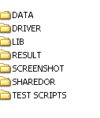
2. ModuleSheet.xls

The Main Module sheet .xls should be available in the folder DRIVER. In that sheet, the respective module execution status must BE “Y” and Enter the Start test case and End test case number, like below.

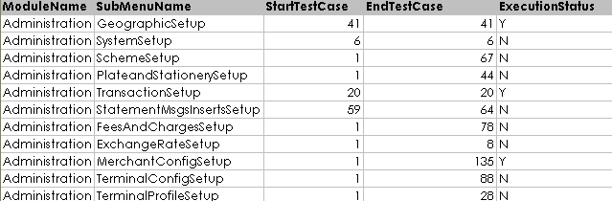

3. Data sheet.

The respective data sheet of the Modules should be kept at the folder DATA which is available under FrameworkMapsII folder.

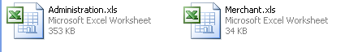

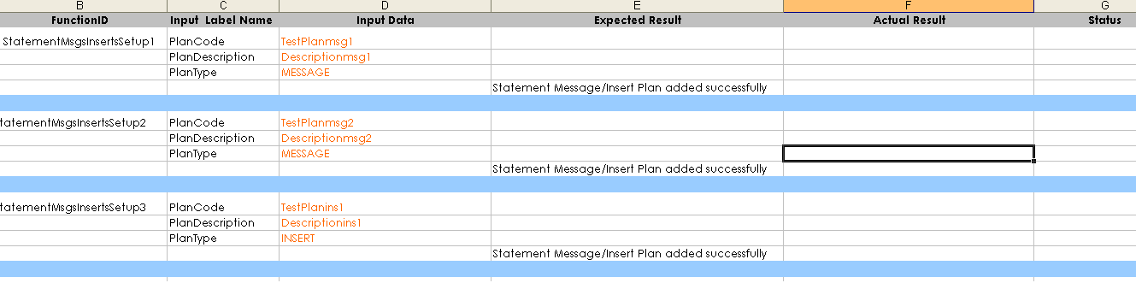
4. Library File Association

The necessary Library file should be associated with main script by doing the following steps.

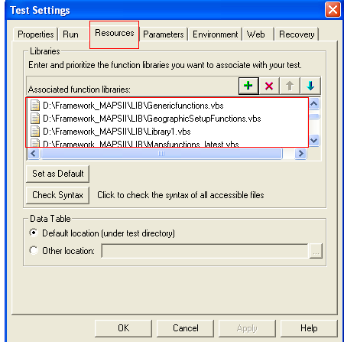

5. Main Script
The main script should be available under the test scripts folder. Invoke QTP and execute the main script.
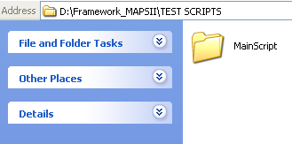
6. Shared Object Repository

The respective Object Repository should be available in the folder Shared OR

